keyboard hook report
28430093 – Alwyn Barnard – ITRW 311 2019

Table of Contents
Introduction 2
Simulation 2
Step 1: Press buttons without the hook 2
Step 2: Press the hook and type input 2
Step 3: Press hook again to disable key logging 2
Code 3

Introduction
A keyboard hook is a program that logs all keys that were pressed. Also referred to as a keylogger program. The keyboard hook is a software layer that lies “on top” of the keys and makes a copy thereof on a different file elsewhere.
These programs are sometimes used to intercept what users are typing in order to gain access to the information that they type.

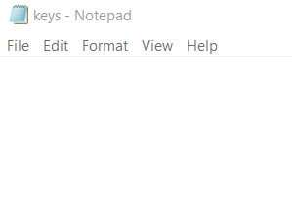
Simulation

Step 1: Press buttons without the hook
Typed “Universe”
No output to file

See figure 1 on right

Step 2: Press the hook and type input
Hook is ShitKey + C.
Typed “Multiverse”

See figure 2 below
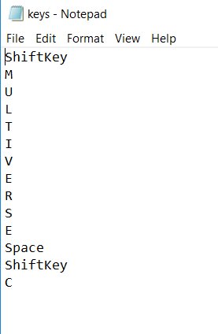

Step 3: Press hook again to disable key logging
Output in file stayed the same. See above figure 2

Code

/*
ALWYN BARNARD
28430093
Keyboard Hook Program
2019 - ITRW 316
Hook starts at press of Shift+C
*/

using System;
using System.Collections.Generic;
using System.ComponentModel;
using System.Data;
using System.Drawing;
using System.Linq;
using System.Text;
using System.Threading.Tasks;
using System.Windows.Forms;
using System.Collections;
using System.IO;

namespace keyboardHook
{
public partial class Form1 : Form
{
ArrayList ElKeys = new ArrayList(); //ElKeys because Keys was reserved
bool start = false;
int count=0;

// StreamReader reader = new StreamReader(str);
public Form1()
{
InitializeComponent();
}

private void Form1_KeyDown(object sender, KeyEventArgs e)
{
if (start == true)
{
ElKeys.Add(e.KeyCode.ToString());
count++;
}
if (e.Shift & e.KeyCode.ToString() == "C")
{

//Toggle true and false
if (start == true) start = false;
else if (start == false) start = true;
}
if ((e.Shift & e.KeyCode.ToString() == "C") && (start==false))
{
StartListening();
}

}
public void StartListening()
{
using (Stream str = new FileStream(@"C:\Users\ALWYN\Downloads\Nodig vir 316_Presentations\KeyBoardHook Program\keys.txt", FileMode.Append, FileAccess.Write))
{
// Declare a StreamWriter object that can be used to write text data to the file
using (StreamWriter writer = new StreamWriter(str))
{
// Write a line of text to the file
for (int i = 0; i < count; i++)
{
writer.WriteLine(ElKeys[i].ToString());
}

}
}
}
}
}

